Order Entry and Shipping Enhancements Specification
Goal: Since the ultimate goal is to streamline shipping processes throughout are existing Load Planning feature within our GS Mobile Functionality, we have to use the existing infrastructure (different SO lines with Qtys and due Dates per Part Number) to support this goal.

Order Entry Process
- New Orders
  - We currently have different ARC Projects that already account for uploading SO Lines from an XLS. Please read these projects and select the best to fit your needs.
  - Please have in mind that we can tweak any of those project to fit your processes 100%
  - 7148 (Simple and easy)– https://docs.gss-service.com/arc/7148
  - 7228 (More Robust)- https://docs.gss-service.com/arc/7228
  - If you want us to read the PDF and create the SO, we can use our GENII AI Feature that has an extra cost per document.
- Change Due Dates on a grid
  - Once an order is uploaded, you have the choice to change the due dates directly on a grid and you have two options:
    - ARC 6830 – Functionality is already built on that (available right now)
    - Use Shipping Dashboard, read below for more details.

Order Parser
- In order to “tell” the shipping personnel that X quantity needs to be shipped on Y day, we need to create an additional SO line with the proper qty and date.
- The proposal is to use the current Shipping Dashboard (7546) that supports the Load Planning feature used in the mobile device
- Proposed Process
  - Select and filter orders that we need to Ship and Assign to Pickers
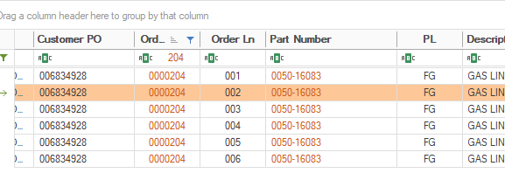
  - Select the lines you want to Ship
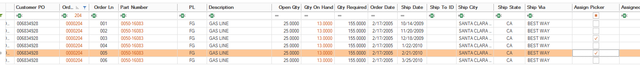
  - Make a right click and click on a new context menu item called “Split SO Line”
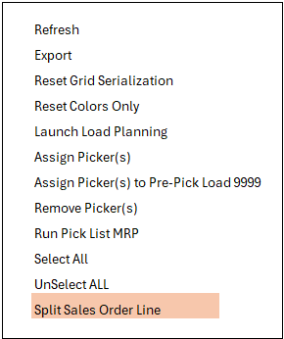
  - 

  - The screen below will pop up and display a gridview with all the records selected from the preview screen, it can support multiple SOs at a time.
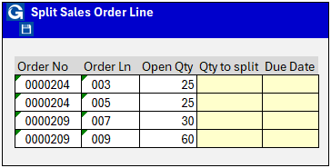
    - User can only interact with cells with yellow background
    - Qty to split field is numerical and the numbers cant be larger or equal than the Open Qty value.
    - Due Date is a date field with a calendar
    - Once the user finishes and clicks SAVE, the program is going to add a NEW Sales Order line into the existing SO# and is going to reduce the Qty on the original line
    - On the new line created, we are going to populate UF5 with the Original Line value that it came from, so its easier for the user to understand where that came from.
    - When the process is over, we will automatically REFRESH the main shipping grid in order to include the new line items
  - Now the user can select and filter the records/SO lines they want to Assign to a picker and utilize the std functionality on that dashboard.
  - There is no UNDO button, if they user needs to fix anything after the new record is created, they will have to Open the actual SO and delete or change the qty on the new line item AND increase the qty on the original line.
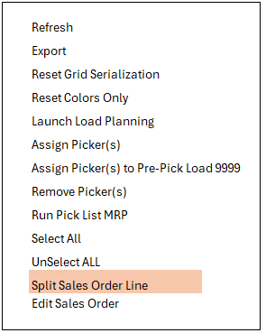
  - If the user has Access to Order Entry > File > Sales Orders > Open he can make a right click on the context menu item and select EDIT Sales Order, which will open the SO in Edit mode and allow to make any changes without leaving the screen.

  - Additionally, by having access to Order Entry > File > Sales Orders > Open the user will be able to change the Ship Due Date directly on the Shipping Dashboard grid.

